Cleaning procedure
Titel:
Cleaning done by users
Application: Symphony
Department: CFFC PKZI | SOP08 | Revision: 6
Created: A.Goddard | Checked: K. Schütze | Date: 28.01.2021

FACSClean causes skin irritation and serious eye irritation.
Wear protective gloves / eye protection.
Wear protective clothing.
If in eyes: Rinse cautiously with water for several minutes. Remove contact lenses, if present and easy to do. Continue rinsing.
If skin irritation occurs: Get medical advice/attention.
If eye irritation persists: Get medical advice/attention.
If on skin: Wash with plenty of water.

You are not allowed to leave any data in your FACSDiva account.
Always export your data to the CFFC server and delete it from your account after you have verified that you can reimport it successfully. For exporting your data only use the path: CFFC/Exported data/”current year”/”your workgroup”/”your CFFC code”/Symphony/”Experiment” and “FCS”.
All data left on the Symphony PC will be deleted during the next system flush.
Hint: check that your data can be displayed.
This can be done during the cleaning.

- Set the black switch at the side of the Symphony to tube.

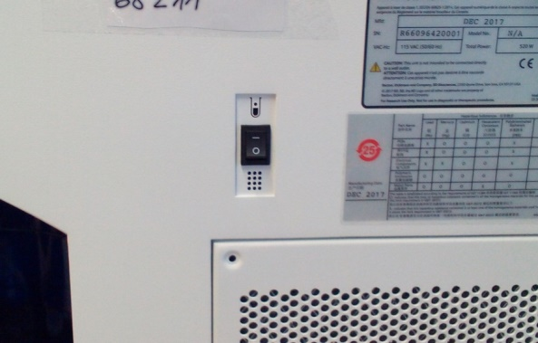 | 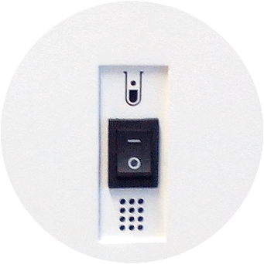

- Log into the cleaning account.
- Use CST settings
- Open the experiment “Cleaning procedure”
- Select specimen “Clean”
- Click “next Tube”
- Rename the tube with your booking code
- Install a tube containing 3 mL of FACSClean on the SIP (Sample Injection Port)
Sample Injection Port (SIP)

- Press RUN and HIGH on the cytometer fluid control panel
- Then press “Acquire” and “Record”. (After 6 minutes the recording will stop automatically)
- With the support arm to the side let it run for 1 minute. (Liquid level will decrease rapidly)

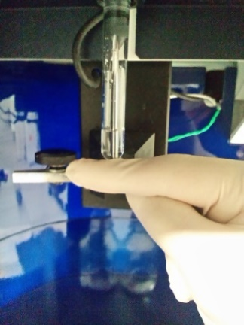 | Support the tube while the arm is to the side, to prevent it from falling down.
- After one minute move the tube support arm under the tube.
- When the recording is finished, replace the FACSClean tube with a tube of FACSRinse solution. With the support arm to the side let it run for 1 minute. After one minute move the tube support arm under the tube and let it run for 5 minutes
- While the FACSRinse solution is running, you can use the time to export your experiment.

- When the FACSRinse has run for 5 minutes select specimen “H2O”
- Click “next Tube”
- Rename the tube with your booking code
- Install a tube containing 3ml of DI water on the SIP
- Press RUN and HIGH on the cytometer fluid control panel
- Then press “Acquire” and “Record”. (After 6 minutes the recording will stop automatically)
- With the support arm to the side let it run for 1 minute. After one minute move the tube support arm under the tube and let it run for 5 minutes
- Press the STANDBY button on the fluidics control panel
- Place a tube containing no more than 1 mL of DI water on the SIP

A tube with 1 mL of DI water should remain on the SIP to prevent salt deposits from forming in the injection tube. This tube also catches back drips from the flow cell.

Check the calendar, to see if you are the last user of the day. If you are, then please shutdown the computer and then switch off the Symphony.

